Dallas County Food Challenge January 21, 2017 / 8:00 AM
Supply Box Certification Form
Club: __________ Age Division: ________ Junior/Intermediate _______Senior
Team Name: ________________________________________________________________
Person completing this form (Print): _____________________________________________
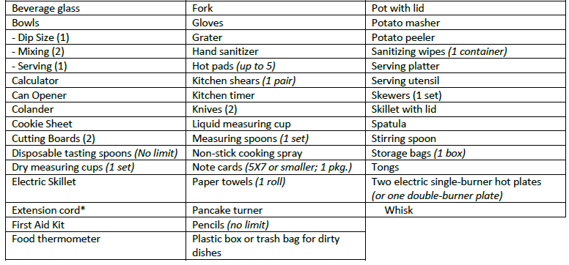
The following is a list of supplies for a 4-H Food Challenge Supply Box. You may choose to have less than what is listed below, however, you may not include any additional items.

*Extension cord should be compatible with your burner requirements (grounded cords are 3-prong; ungrounded cords are 2-prong)
Acknowledgement
I understand that my team’s supply box must include only those items and quantities listed above, and that I am not permitted to have any additional items in the supply box. I also understand that I may be selected for a random inspection, or spot inspection prior to or during the contest. I understand that I cannot share a box or supplies in a box with anyone competing simultaneously with my team. If my box has any items not listed above or not in accordance with this list, I am aware that my team will be assessed penalty points.
_____________________________________________________
Team Member Signature Date
_____________________________________________________
Parent/Leaders Signature Date
This form must be submitted to the Supply Box Check-In Superintended prior to the contest.

