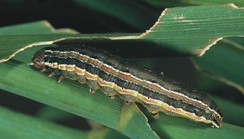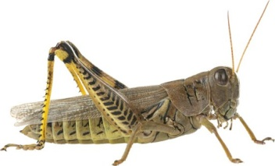 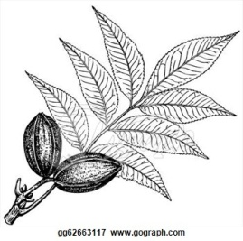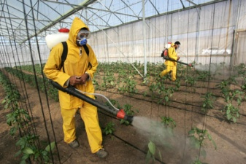

# Private Pesticide

# Applicator Training

***This 4 Hour Training will prepare you to take the Private Applicator License test.***

**Date: Thursday, September 21, 2017**

**Training Time: 8:30 am – 12:00 pm**

**Where: *Texas A&M Engineering Extension Service***

***15515 I-20 @ Lumley Mesquite, TX 75181***

[*https://goo.gl/maps/ZXatVde15XM2*](https://goo.gl/maps/ZXatVde15XM2)

***Limited seating***

***Please register by Monday, September 18th***

Register using the link below or QR Code:

<http://dallas-tx.tamu.edu/agriculture-and-natural-resources/pesticide-applicator-license-training/>



**Cost $55.00**

**Includes study materials to take the license test.**

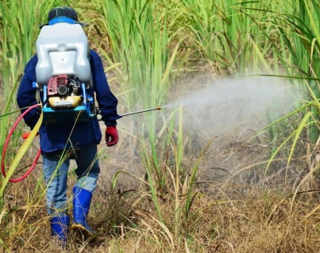

Who needs a license?

A person who uses or supervises the use of restricted-use or state-limited-use pesticides or regulated herbicides for the purpose of producing an agricultural commodity on property owned or rented by the person or the person's employer or under the person's general control.



|  |
| --- |
|  |
|  |

The members of Texas A&M AgriLife will provide equal opportunities in programs and activities, education, and employment to all persons regardless of race, color, sex, religion, national origin, age, disability, genetic information, veteran status, sexual orientation or gender identity and will strive to achieve full and equal employment opportunity throughout Texas A&M AgriLife. Texas A&M AgriLife will strictly comply with all…“*The Texas A&M University System, U.S. Department of Agriculture, and the County Commissioners Courts of Texas Cooperating*”. ***If you require special accommodations to attend this program, please email me by registration deadline to see what reasonable accommodations can be made.***