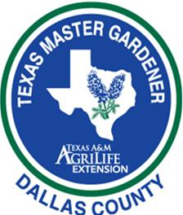

2018 Dallas County Master Gardener School Topics/Presenters

DATE TOPIC PRESENTER TIME
January 8 Orientation Stephen Hudkins School Staff 10-1
January 15 Martin Luther King Day No Class
January 22 Soils & Compost Stephen Hudkins ½ Day
January 22 Plant Growth & Development Jayla Fry ½ Day
January 29 Entomology Dr. Mike Merchant Full Day
February 5 Rain Water Harvesting & Dr. Dotty Woodson ½ Day
February 5 Landscape Planning Bonnie Reese ½ Day
February 12 Trees Steve Houser Full Day
February 19 Fruits, Pecans, Berries Dr. Larry Stein Full Day
February 26 Propagation Workshop Roseann Ferguson ½ Day
Tom Wilten ½ Day
March 5 Plant Pathology Dr. Kevin Ong Full Day
March 12 NTX Vegetable Gardening Stephen Hudkins Full Day
Field Workshop Jeff Raska
March 19 Earth-Kind®;/Shade Plants Laura Miller Full Day
March 26 Perennials & Bulbs Steve Huddleson Full Day
April 2 Turf Grass Stephen Hudkins Full Day
April 9 Organic Gardening Skip Richter Full Day
April 16 Help Desk & Diagnostic Workshop Stephen Hudkins Full Day
April 23 Last Day of School School Coordinators Full Day
Final Exam
April 30 Snow Make Up Day if Needed

PROGRAM LOCATIONS WILL VARY BETWEEN THE EXTENSION LEARNING CERNTER, ROWLETT ROAD SATELLITE OFFICE, AND RAINCATCHERS R.E.D. GARDEN

