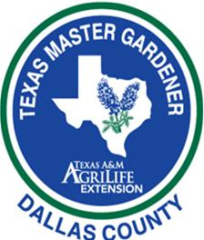

2019 Dallas County Master Gardener School Topics/Presenters

DATE TOPIC PRESENTER TIME
January 7 Orientation Stephen Hudkins School Staff 10-1
January 14 Soils & Compost Stephen Hudkins ½ Day
January 14 Plant Growth & Development Jayla Fry ½ Day
January 21 Martin Luther King Day No Class
January 28 Entomology Dr. Mike Merchant Full Day
February 4 Rain Water Harvesting & TBA ½ Day
February 4 Landscape Planning Bonnie Reese ½ Day
February 11 Trees Steve Houser Full Day
February 18 Fruits, Pecans, Berries Dr. Larry Stein Full Day
February 25 Propagation Workshop Roseann Ferguson ½ Day
Tom Wilten ½ Day
March 4 Plant Pathology Dr. Kevin Ong Full Day
March 11 NTX Vegetable Gardening Stephen Hudkins Full Day
Field Workshop Jeff Raska
March 18 Earth-Kind®;/Shade Plants TBA Full Day
March 25 Perennials & Bulbs Steve Huddleson Full Day
April 1 Turf Grass Stephen Hudkins Full Day
April 8 Organic Gardening Skip Richter Full Day
April 15 Help Desk & Diagnostic Workshop Stephen Hudkins Full Day
April 22 Last Day of School School Coordinators Full Day
Final Exam
April 29 Snow Make Up Day if Needed

ALL TRAINING SESSIONS WILL BE HELD AT THE EXTENSION LEARNING CERNTER AT THE ROWLETT ROAD SATELLITE OFFICE LOCATED AT 715 ROWLETT ROAD, GARLAND, TX 75040

