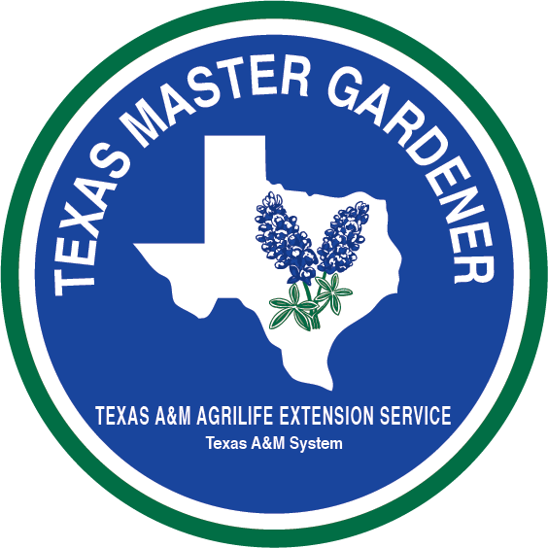

Master Gardener Advanced Vegetable Training
February 13,14,15, 2019
Texas A&M AgriLife Extension Service/Dallas County Satellite Office
715 Rowlett Road, Garland, TX 75040

Advanced Program Purpose:
To provide advanced training whereby Master Gardeners can obtain advanced training in areas that support or expand designed programs of Texas A&M AgriLife Extension Service.

Master Gardener Advanced Vegetable Training:
The Master Gardener Advanced Vegetable Training was created as a hands-on, intensive multi-day training that will empower you with knowledge and skills required to effectively support and multiply Texas A&M AgriLife Extension efforts in educational programs.

Master Gardeners who have advanced training and volunteer requirements will be recognized as a Advanced Master Gardener – Vegetables. This certification does not empower the individual with supervisory or administrative authority within his/her local county programs.

Participation Requirements:
To be eligible for the Advanced Master Gardener Vegetable training, an individual must possess an up-to-date Master Gardener certification or be an employee of the Texas A&M AgriLife Extension Service. Your application must be approved by your local County Extension Agent.

Advanced Master Gardener - Vegetables:
The Advanced Master Gardener Vegetable program is designed to train and certify Master Gardeners to become part of a state corps of volunteer experts and educators. To become a certified Advanced Master Gardener - Vegetables, you are required to attend the Advanced Master Gardener- Vegetable training to fulfill training requirements and subsequently meet service requirements described below. Training activities during the course will empower you to complete these service requirements.

Time Commitment:
You are required to serve a minimum of one year as an Advance Master Gardener -Vegetables to providing a minimum of 20 hours of service.

Training and Service Requirements:
- Attend the Advanced Master Gardener- Vegetables training
- Serve as a local Advanced Master Gardener- Vegetables resource
- Assist with Advanced Master Gardener-Vegetables training for Master Gardeners and trainees
- Conduct community/youth vegetable education programs
- Increase clientele knowledge about Vegetables through: presentation, workshops and mass media efforts ( i.e. radio, newspaper, television, newsletters)

Advanced Master Gardener Recognition and Certification:
Upon completion of the Advanced Master Gardener- Vegetables service requirements, you will be formally recognized at the annual Texas Master Gardener Conference, at which time you will be awarded an Advanced Master Gardener-Vegetables Certificate and lapel pin.

Resources Available to Advanced Master Gardener- Vegetables:
Direct access to Texas A&M AgriLife Extension Service County Extension Agent – Horticulture Free Soil Test coupon.

- Three Free vegetable books
- Jump drive with over 1200 files including power points from training
- Pocket loupe for insect ID

If you need any special accommodations, please contact Steve Hudkins at 214-904-3050 by January 15, 2019 so we can consider your request.

Texas A&M AgriLife Extension provides equal opportunities in its programs and employment to all person, regardless of race, color, sex, religion, national origin, disability, age, genetic information, veteran status, sexual orientation, or gender identity.”
The Texas A&M University System, U.S. Department of Agriculture, and the County Commissioners Courts of Texas Cooperating.”

Texas A&M AgriLife Extension Service
Dallas County, Dallas, Texas
February 13-15, 2019

Registration Form

PLEASE PRINT CLEARLY
Name: ________________________________________________________________ Address: _____________________________________________________________ City: __________________________ State:_________ Zip: _________
Phone Number: _______________________________________________________
E-mail: ______________________________________________________________
Chapter: __________________________ County: ___________________________

Required MG Coordinator/Agent Signature: _______________________________

PLEASE ASK YOUR COUNTY EXTENSION AGENT TO FAX REGISTRATION FORM TO 214-904-3080 To insure meeting the deadline.

Registration fee: $ 235.00
(Includes dinner (1) (Wednesday Night), lunch (2), snacks, drinks, equipment,
jump drive and resource materials distributed during course).

Spouse would like to attend Monday night dinner: $20.00 $ ______ Vegetable denim Shirt for and additional $32.00 $ ______ Vegetable Baseball Cap $ 9.00 $ ______ TOTAL…………………………………………………………………………..…$ ______

If you have any special dietary needs, please contact Steve Hudkins at 214-904-3050 or stephen.hudkins@ag.tamu.edu by January 15, 2019

Please check:
Shirt Size: Ladies________ Men________ Short Sleeve _____ Long Sleeve _____

S _____ M _____ L _____ XL _____ XXL ______ XXXL ____

- Transportation and lodging are on your own.
- Course is limited to the first 50 applicants to send check and application.
- A maximum of 4 Master Gardeners from each county.
- After the deadline registration will be reopened if enrollment is not reached

Deadline: January 15, 2019

We must order supplies in advance so there will be no refunds after January 31, 2019

Mail check made payable to:
(Horticulture Committee) along with the registration form to:
Advanced Master Gardener -Vegetables Training
Texas A&M AgriLife Extension Service
10056 Marsh Lane, Suite B-101
Dallas, TX 75229

For more information Contact:
Steve Hudkins: (Stephen.hudkins@ag.tamu.edu) - 214-904-3050

Texas A&M AgriLife Extension provides equal opportunities in its programs and employment to all person, regardless of race, color, sex, religion, national origin, disability, age, genetic information, veteran status, sexual orientation, or gender identity.”
The Texas A&M University System, U.S. Department of Agriculture, and the County Commissioners Courts of Texas Cooperating.”

Advanced Master Gardener Vegetable Training
February 13-15. 2019

Advanced Master Gardener Vegetable Training course will include high quality training combined with hands-on experience.

Course Location:
Texas A&M AgriLife Extension Service Satellite Office
715 Rowlett Road, Garland, TX 75040 Phone: (214) 904-3050 or (Cell) 214-952-0519

Accommodations:
- Transportation to Dallas will be on your own.

Cost:
Registration fee of $235.00 per person includes:
- 2 Lunches, 1 dinner, snacks and drinks
- Advanced Vegetable training
- Direct access to Texas AgriLife Extension Service County Extension Agent – Horticulture
- Free Soil Test coupon
- Three Free vegetable books
- Jump drive with over 1200 files including power point presentations from training
- Pocket loupe for insect ID
- All required materials and supplies

***Denim Vegetable shirt available for additional $32.00. Please select size on registration form and add $32.00 to your payment.

***Vegetable Baseball Cap available for an additional $9.00 (add to total)

DRESS: Dress casually, wear comfortable closed toe shoes and bring insect repellent.
For more information, contact Steve Hudkins, Extension Horticulturist, 214-904-3050 or
Stephen.hudkins@ag.tamu.edu

Agenda

Wednesday-February 13, 2109
1:00 p.m. Welcome and Introductions:
Stephen Hudkins, CEA Dallas County, and
Steve Chaney, CEA Tarrant County

1:15 p.m. Organic Production- Skip Richter
2:30 p.m. Break

2:45 p.m Overview of Vegetable Crops -Skip Richter
Tomatoes, Peppers, Cucurbits, Mellon, Greens, onions, carrots, etc
4:30 p.m. Variety Selection For Texas Gardens – Steve Chaney
Utilizing The Planting Guides – Jeff Raska & Steve Chaney
Spring and Fall

5:00 p.m. Program Ends
6:00 p.m. Dinner (Included with registration)

Agenda

Thursday-February 14, 2019
8:00 a.m. Assemble-Coffee
8:30 a.m. Factors To Consider When Planning A Garden – Steve Hudkins &Jeff Raska
Location - Site selection
Soil Type-Soil properties
Water availability
How much produce do you need- yield expectations
8:45 a.m. Row Garden Soil Preparation – Steve Chaney & Jeff Raska
Soil Test-Yes or No and Why
The lasagna approach
Mulch vs. compost

9:00 a.m. Raised Beds* - Steve Hudkins
Construction materials
Soil materials, Size, Cost

9:30 a.m. Watering and Irrigation – Jeff Raska
Drip Irrigation
Rain Barrels

10:00 a.m. Break

10:15 a.m. Hands on Workshop building the Raised Bed and Drip Irrigation system

11:30 a.m. Leave for Field Trip

12:15 p.m. Lunch (Included with Registration)
1:00 p.m. Field Trip – IBOC Church swale and terrace in ground system community garden, Paradise Missionary Baptist Church-raised bed gardens, Geneva Heights School Garden

5:00 p.m. End of Session

6:00 p.m. Dinner on your own

Agenda
Friday-February 15, 2019

8:30 a.m. Assemble and Coffee

8:45 a.m. IPM Weed Control & Calibration- Steve Hudkins
9:45 a.m. Container and Patio Gardening What Works and What Does Not Work – Lisa Patterson
Herbs- Barbara Gollman, DCMG
10:30 a.m. Break
10:45 a.m How did I do it? – Larry Thompson, Advanced Master Gardener

11:15 a.m. Questions and Answers
12:00 p.m. Session Ends
INSTRUCTORS:
Mr. Steve Chaney, CEA/Horticulture, Tarrant County
Mr. Skip Richter, CEA/Horticulture, Harris County
Ms. Lisa Patterson, Dallas County Advanced Master Gardener-Vegetables
Mrs. Barbara Gollman, Dallas County Advanced Master Gardener – Vegetables
Mr. Larry Thompson, Dallas County Advanced Master Gardener – Vegetables
Mr. Steve Hudkins, CEA/Horticulture, Dallas County
Mr. Jeff Raska, Horticulture Program Assistant, Dallas County

Texas A&M AgriLife Extension provides equal opportunities in its programs and employment to all person, regardless of race, color, sex, religion, national origin, disability, age, genetic information, veteran status, sexual orientation, or gender identity.”
The Texas A&M University System, U.S. Department of Agriculture, and the County Commissioners Courts of Texas cooperating.”

